Unsupervised Classification (clustering). https://developers.google.com/earth-engine/guides/clustering

Clusterers are used in the same manner as classifiers in Earth Engine. The general workflow for clustering is:

1. Assemble features with numeric properties in which to find clusters.

2. Instantiate a clusterer. Set its parameters if necessary.

3. Train the clusterer using the training data.

4. Apply the clusterer to an image or feature collection.

5. Label the clusters.

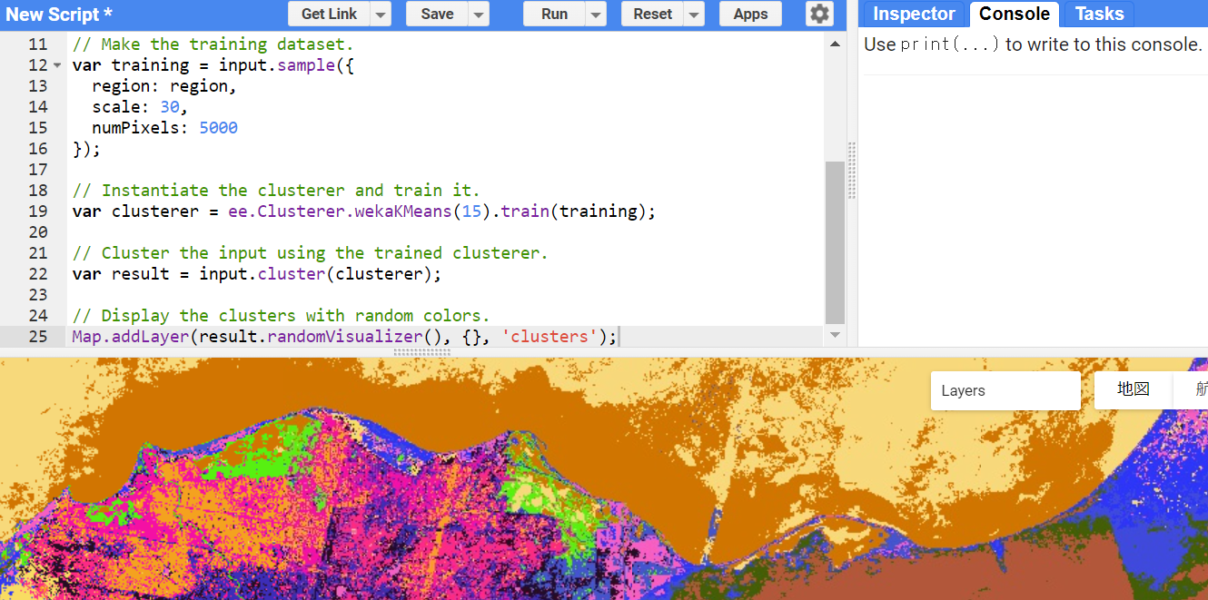

// Load a pre-computed Landsat composite for input.

var input = ee.Image('LANDSAT/LE7_TOA_1YEAR/2001');

// Define a region in which to generate a sample of the input.

var region = ee.Geometry.Rectangle(29.7, 30, 32.5, 31.7);

// Display the sample region.

Map.setCenter(31.5, 31.0, 8);

Map.addLayer(ee.Image().paint(region, 0, 2), {}, 'region');

// Make the training dataset.

var training = input.sample({

region: region,

scale: 30,

numPixels: 5000

});

// Instantiate the clusterer and train it.

var clusterer = ee.Clusterer.wekaKMeans(15).train(training);

// Cluster the input using the trained clusterer.

var result = input.cluster(clusterer);

// Display the clusters with random colors.

Map.addLayer(result.randomVisualizer(), {}, 'clusters');